🚩 Flag vs. Banner vs. Sign — What’s the Difference?
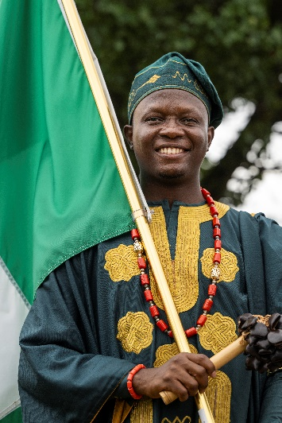
For events like Celebration of Nations, each item helps represent culture, identity, and community in a different way!

📍 FLAG
Represents a country, culture, or identity.
Usually carried proudly during parades and ceremonies.
Example: Country flags during the procession.

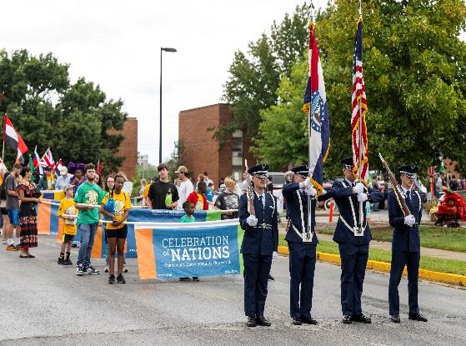
📍 BANNER
Large display with event names, themes, or organization branding.
Great for leading groups and creating visibility.
Example: “Celebration of Nations” parade banner.

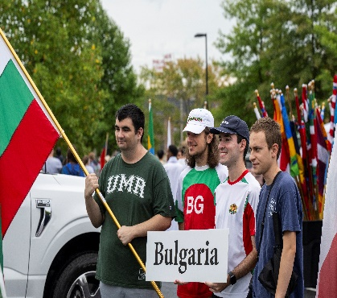

📍 SIGN
Provides information, directions, or labels.
Can identify countries, booths, activities, or announcements.
Example: Country name signs or welcome signs.

